Sony Ericsson lansează Xperia™ arc – un smartphone cu design ultra-subţire, ce rulează pe ultima versiune de Android 2.3

- Xperia™ arc combină designul ultra-subţire cu tehnologiile inovatoare Sony de redare a imaginilor, pe platforma Android 2.3
- Ecran multi-touch de 4.2” şi Reality Display cu procesor de imagine Mobile BRAVIA® Engine ce asigură o calitate foarte bună a imaginilor redate
- Cameră foto de 8.1 megapixeli şi funcţie de filmare HD

06 Ianuarie 2011, Bucureşti – Sony Ericsson a lansat noul telefon Xperia™ arc, ce are la bază cele mai performante tehnologii Sony de redare a imaginilor şi rulează pe ultima versiune a platformei Android – 2.3. Xperia™ arc este primul model dintr-o generaţie nouă de telefoane Xperia™ care vor fi lansate în 2011.

Bert Nordberg, preşedintele Sony Ericsson a declarat “Am început în forţă anul 2011 prin lansarea celui mai performant telefon Xperia™ care există la acest moment pe piaţă. Xperia™ arc combină tehnologiile revoluţionare Sony cu un design unic, pentru a oferi consumatorilor experienţe noi; toate acestea pe ultima versiune de Android™ - 2.3”.

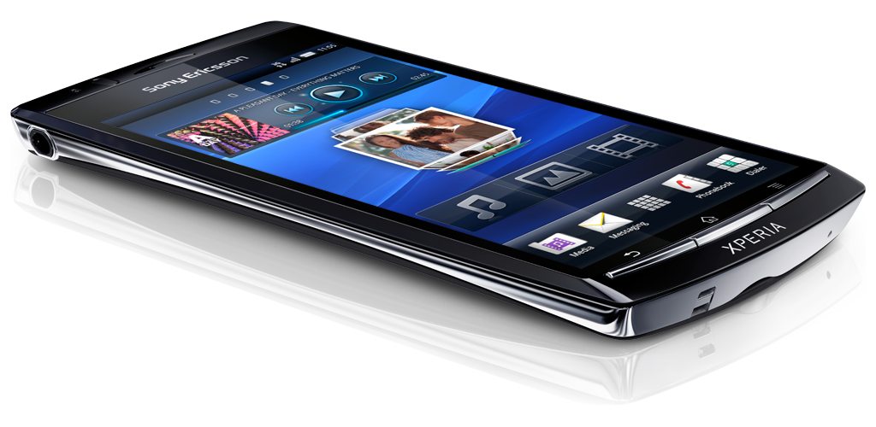

Xperia™ arc vine cu un design unic, specific telefoanelor Sony Ericsson. Ultra-subţire şi uşor (117 grame), Xperia™ arc are doar 8.7 mm în partea cea mai subţire şi un ecran multi-touch de 4.2”. Realizat din materiale premium, cu un corp arcuit, telefonul este rezistent şi se mulează perfect în mâinile utilizatorilor.

Xperia™ arc încorporează cele mai performante tehnologii Sony. Reality Display cu procesorul de imagine Mobile BRAVIA® Engine oferă o calitate excepţională a imaginii, culori luminoase şi detalii îmbunătăţite. Mai mult decât atât, senzorul de înaltă rezoluţie Exmor R™ de la Sony, cu lentile f/2.4, folosit şi la aparatele foto Sony Cybershots, asigură redarea fotografiilor clare şi luminoase şi înregistrări HD, chiar şi la lumină scăzută. Toate fotografiile şi înregistrările pot fi vizualizate la calitate HD pe televizor, cu ajutorul conectorului încorporat HDMI.

Xperia™ arc funcţionează pe cea mai nouă versiune de Android™ şi asigură acces la Google Mobile Services şi la mulţimea de aplicaţii disponibile pe Android market.

Sony Ericsson Xperia™ arc – Principalele caracteristici
- Subţire, uşor şi rezistent, respectă curbura naturală a mâinii
- Ecran multi-touch de 4.2” şi Reality Display cu procesor de imagine Mobile BRAVIA® Engine ce asigură o calitate foarte bună a imaginilor redate
- Senzor Sony Exmor R™ pentru telefoane mobile: fotografii şi înregistrări de înaltă rezoluţie
- Cameră foto de 8.1 megapixeli şi funcţie de filmare HD
- Android Market™ – acces la mii de aplicaţii

Sony Ericsson Xperia™ arc va fi disponibil în România începând cu primul trimestru al anului 2011.

Pentru mai multe informaţii, consultaţi blogul Sony Ericsson: http://blogs.sonyericsson.com/products

- SFÂRŞIT -

Sony Ericsson Xperia™ arc dintr-o privire

Cameră foto | 8.1 megapixel camera  Up to 2.46x smart zoom  Aperture f/2.4  Auto focus  Face detection  Flash/LED  Geo tagging  Image stabilizer  Noise suppression  Send to web  Smile detection  Sony Exmor R™ for mobile CMOS sensor  Touch Focus  Touch capture  Video light  Video recording, HD 720p
Music | Album art  Bluetooth™ stereo (A2DP)  Media player  Music tones (MP3/AAC)  PlayNow™ service*  TrackID™ music recognition application  * This service may not be available in every market
Web | Bookmarks  Google™ search  NeoReader™ barcode scanner  Pan & zoom  Web browser (WebKit)
Communication | Call list  Conference calls  Facebook™ application*  Sony Ericsson Timescape™  Speakerphone  Vibrating alert  * This service may not be available in every market
Messaging | Conversations  Email  Microsoft® Exchange ActiveSync®  Instant messaging  Picture messaging (MMS)  Predictive text input  Sound recorder  Text messaging (SMS)
Design | Auto rotate  Keyboards (onscreen, QWERTY)  Picture wallpaper  Reality display  Sony Mobile BRAVIA® Engine  Touchscreen  Wallpaper animation
Entertainment  * This service may not be available in every market | 3D games  Media browser  Motion gaming  Radio (FM)  Video streaming  Video viewing  YouTube™ *
Organiser | Android™ OS  Alarm clock  Calculator  Calendar  Document readers  Flight mode  Infinite button  Phone book
Connectivity | 3.5 mm audio jack  aGPS  Bluetooth™ technology  Google Maps™  HDMI  Modem  DLNA  USB mass storage  USB support  Wi-Fi™  Wisepilot™ turn-by-turn navigation *  * This service may not be available in every market
Google™ services*  * These services may not be available in every market | Android Market™ Client  Gmail™  Google Calendar™  Google Gallery 3D™  Google Latitude™  Google Maps™ with Street View  Google Media Uploader  Google Music Player™  Google Phone-top Search  Google Search widget  Google Sync™  Google Talk™  Google Voice Search  Set-up Wizard  YouTube™
Screen | Sony Mobile Bravia Engine  16,777,216 colour TFT  Capacitive multi-touch  4.2 inches  854 x 480 pixels (FWVGA)  Shatter proof sheet on scratch-resistant mineral glass
Accessories | In-Box:  - Sony Ericsson Xperia™ arc  - Battery (1500mAh)  - Stereo portable handsfree  - Micro USB cable for charging, synchronisation and file transfer  - User documentation
Facts 1)2) | Size: 125 x 63 x 8.7 mm  Weight: 117 grams  Phone memory: Up to 512 MB  Memory card support: up to 32 GB  Memory card included: microSD™ 8 GB  Operating system: Google™ Android 2.3  Processor: 1 GHz Qualcomm
Availability and versions | Networks  UMTS HSPA 900, 2100  GSM GPRS/EDGE 850, 900, 1800, 1900  UMTS HSPA 800, 850, 1900, 2100  GSM GPRS/EDGE 850, 900, 1800, 1900
Colour | Midnight Blue  Misty Silver

PENTRU MAI MULTE INFORMAŢII, VĂ RUGĂM CONTACTAŢI:
Anda Copăceanu, PR Consultant, Rogalski Grigoriu Public Relations
E-mail: anda.copaceanu@r-g.ro
Telefon: 0743 121 235

Legal
1) Facts and features may vary depending on local variant. 2) Operational times are affected by network
preferences, type of SIM card, connected accessories and various activities e.g. playing games. Kit contents and colour options may differ from market to market. The full range of accessories may not be available in every market.

© Sony Ericsson Mobile Communications AB, 2011

The Liquid Identity logo and Xperia are trademarks or registered trademarks of Sony Ericsson Mobile Communications AB. Sony is a trademark or registered trademark of Sony Corporation. Ericsson is the trademark or registered trademark of Telefonaktiebolaget LM Ericsson. Additional information regarding trademarks may be located on our website at: www.sonyericsson.com/cws/common/legal/disclaimer.

Other product and company names mentioned herein may be the trademarks of their respective owners. Any rights not expressly granted herein are reserved. All terms are subject to change without prior notice.
Sony Ericsson Mobile Communications AB, SE-221 88 Lund, Sweden.
Printed in January 2010, R1A

Sony Ericsson is a 50/50 joint venture by Sony and Ericsson established in October 2001, with global corporate functions located in London and operations in major markets around the world. Sony Ericsson’s strategy is to become the industry leader in mobile Communication Entertainment, through new styles of interaction across the internet and social media. Sony Ericsson offers exciting consumer experiences through innovative and feature rich phones, accessories, content and applications. For more information, please see: www.sonyericsson.com/press.

